**Mission 1**

sysadmin@UbuntuDesktop**:~$ nslookup -type=MX starwars.com**

Server: 8.8.8.8

Address: 8.8.8.8#53

Non-authoritative answer:

starwars.com mail exchanger = 10 aspmx2.googlemail.com.

starwars.com mail exchanger = 1 aspmx.l.google.com.

starwars.com mail exchanger = 5 alt1.aspx.l.google.com.

starwars.com mail exchanger = 5 alt2.aspmx.l.google.com.

starwars.com mail exchanger = 10 aspmx3.googlemail.com.

Authoritative answers can be found from:

From the lookup above, the URLs listed above are not correct.

The correct URLs are.

starwars.com mail exchanger = 1 asltx.l.google.com.

starwars.com mail exchanger = 5 asltx.2.google.com.

**Mission 2**

**$ nslookup -type=SPF theforce.net**

Server: 8.8.8.8

Address: 8.8.8.8#53

Non-authoritative answer:

*** Can't find theforce.net: No answer

Authoritative answers can be found from:

theforce.net

origin = WebPublish_Othe

mail addr = hostmaster

serial = 2017110901

refresh = 900

retry = 600

expire = 86400

minimum = 3600

nslookup shows IP address for theforce.net is 104.156.250.80.

sysadmin@UbuntuDesktop**:~$ nslookup theforce.net**

Server: 8.8.8.8

Address: 8.8.8.8#53

Non-authoritative answer:

Name: theforce.net

Address: 104.156.250.80

It still has an old IP address of 104.156.250.80 which shows Force hasn’t updated the IP address. Since IP address was changed during DOS attack, it should be changed to new IP address.

The correct IP address is 45.23.176.21.

**Mission 3**

sysadmin@UbuntuDesktop**:~$ nslookup -type=CNAME www.theforce.net**

Server: 8.8.8.8

Address: 8.8.8.8#53

Non-authoritative answer:

www.theforce.net canonical name = theforce.net.

Authoritative answers can be found from:

*Explain why the sub page of resistance.theforce.net isn't redirecting to theforce.net.*

The DNS CNAME record is missing a reference from resistance.theforce.net to [www.theforce.net](http://www.theforce.net)

Corrected DNS record should be.

www.theforce.net cname = theforce.net.

resistance.theforce.net cname = [www.theforce.net](http://www.theforce.net).

**Mission 4**

DNS record for princessleia.com

sysadmin@UbuntuDesktop**:~$ nslookup -type=NS princessleia.site**

Server: 8.8.8.8

Address: 8.8.8.8#53

Non-authoritative answer:

princessleia.site nameserver = ns25.domaincontrol.com.

princessleia.site nameserver = ns26.domaincontrol.com.

To fix this issue and prevent it from happening again add the ns record.

princessleia.site nameserver = ns2.galaxybackup.com

**Mission 5**

Shortest path from Batuu to Jedha

D—C—E—F—J—I—L—Q—T—V

The path above doesn’t go through Planet N.

**Mission 6**

sysadmin@UbuntuDesktop:~/Downloads**$ aircrack-ng Darkside.pcap -w rockyou.txt**

Opening Darkside.pcap

Read 586 packets.

# BSSID ESSID Encryption

1 00:0B:86:C2:A4:85 linksys WPA (1 handshake)

Choosing first network as target.

Opening Darkside.pcap

Reading packets, please wait...

Aircrack-ng 1.2 rc4

[00:00:02] 2284/9822769 keys tested (1050.31 k/s)

Time left: 2 hours, 35 minutes, 52 seconds 0.02%

KEY FOUND! [ dictionary ]

Master Key : 5D F9 20 B5 48 1E D7 05 38 DD 5F D0 24 23 D7 E2

52 22 05 FE EE BB 97 4C AD 08 A5 2B 56 13 ED E2

Transient Key : 1B 7B 26 96 03 F0 6C 6C D4 03 AA F6 AC E2 81 FC

55 15 9A AF BB 3B 5A A8 69 05 13 73 5C 1C EC E0

A2 15 4A E0 99 6F A9 5B 21 1D A1 8E 85 FD 96 49

5F B4 97 85 67 33 87 B9 DA 97 97 AA C7 82 8F 52

EAPOL HMAC : 6D 45 F3 53 8E AD 8E CA 55 98 C2 60 EE FE 6F 51

sysadmin@UbuntuDesktop:~/Downloads$ **sudo wireshark**

[sudo] password for sysadmin:

17:55:51.037 Main Warn QStandardPaths: XDG_RUNTIME_DIR not set, defaulting to '/tmp/runtime-root'

18:01:33.761 Main Warn FIX Add drag reordering to UAT dialog

18:06:44.747 Main Warn FIX Add drag reordering to UAT dialog

18:07:18.836 Main Warn FIX Add drag reordering to UAT dialog

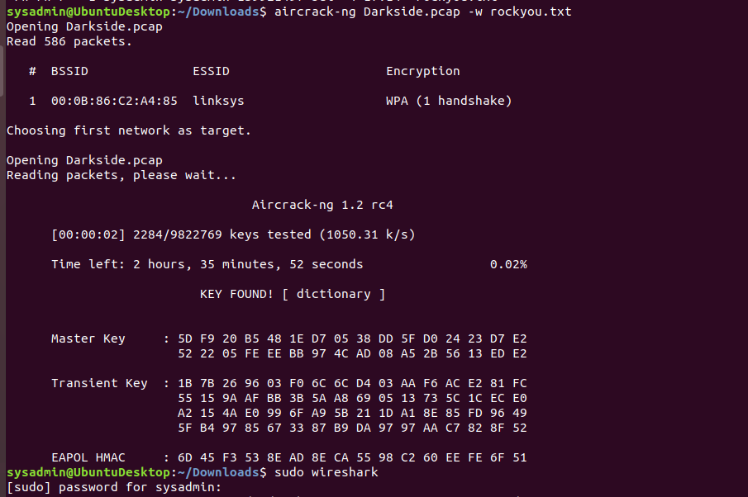

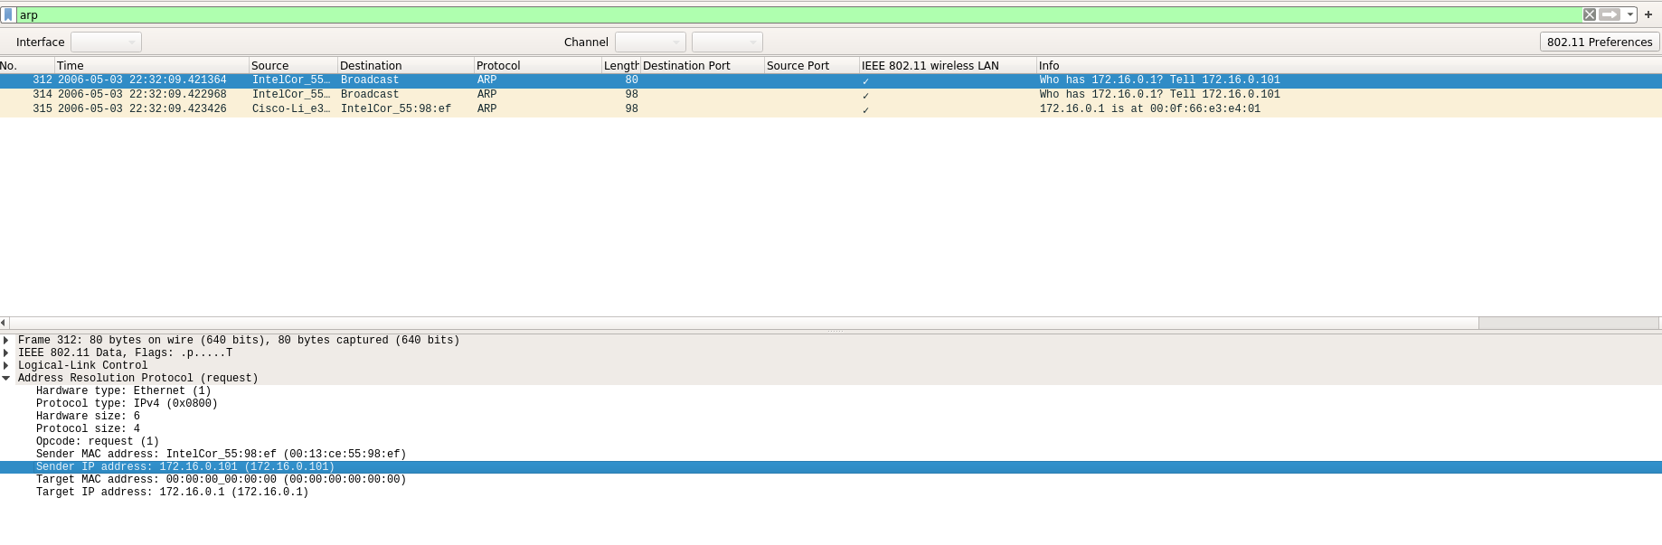

**Host IP Addresses = 172.16.0.101, MAC Addresses = 00:13:ce:55:98:ef)**

**Host IP Address = 172.16.0.1, MAC Address = 00:0f:66:e3:e4:01)**

**DNS (of interest) = ns1.ri.cox.net**

**Mission 7**

**Nslookup -type=TXT princessleia.site**

